Technology Skills: HTML

Project: Digital Ethics/Cyberbullying

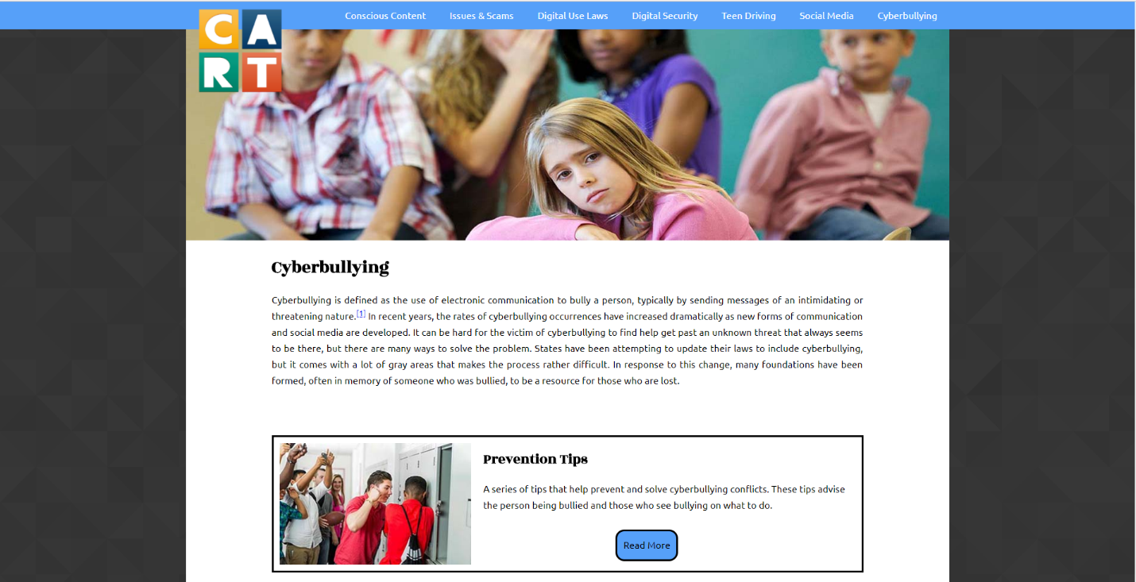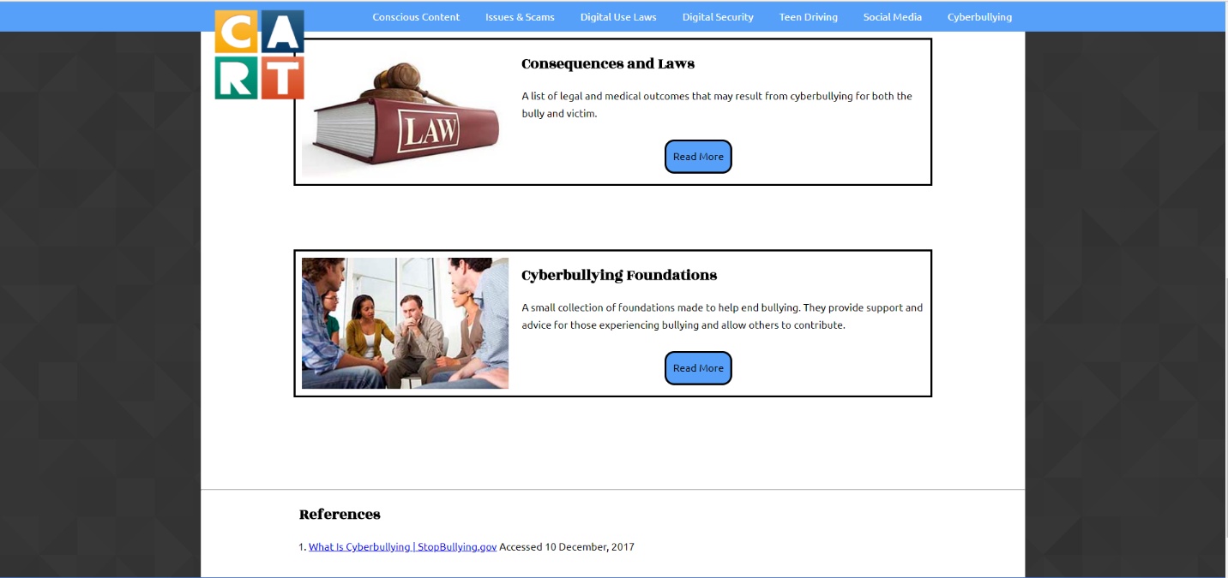

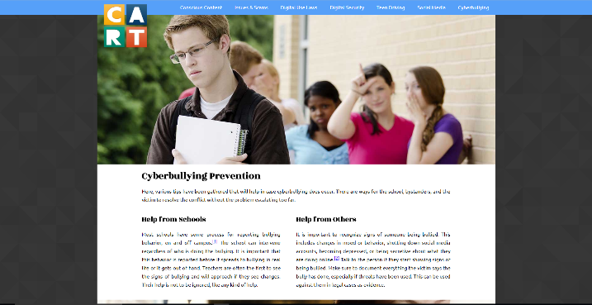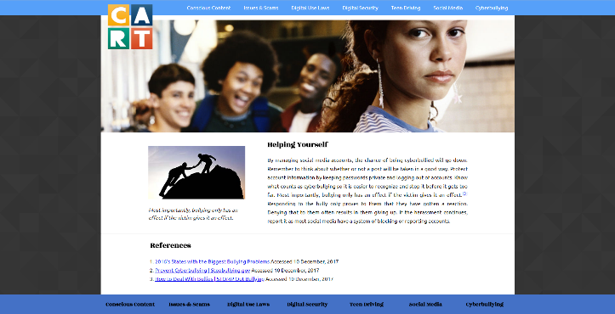

This project was a website that contained information about digital ethics and using the Internet responsibly. My entire web design class worked together to make the whole website. These screenshots are of one of the pages I coded myself. While the navigation bar was not my doing, I created everything else from the ground up. It was created using HTML and CSS programming. HTML is a programming language that places the basic content, including pictures and text. CSS is the language that formats that content into what you see.

The process had many ups and downs as I made the pages. It was difficult finding the right size for the pictures. If it was too big, the text would be moved around and not look nice. If they are too small, they wouldn’t look as good. The banner picture was especially annoying to place for those reasons. Once I did I was so proud with the final product. Working the media queries was also difficult when it came to formatting the text. Media queries allow a web page to adapt in size depending on the screen. For example, if someone view the website on a phone, they don’t get the original sized website, but a smaller, more mobile-friendly sized page. Setting the text to fit well on the page on a smaller screen was a difficult process that still isn’t fully finished.

I had to stay persistent in my work to create pages of this quality. I also had to be as accurate as possible when it came to the information presented. The same can be said about my design process. I focused on the pages being clean and interesting when creating them. Throughout the project, the entire class could find a little humor when something went horribly wrong when coding. It was small things like that which allowed everyone to stay determined on the website by finding humor to lighten up the mistakes.